Single Path Routing and Network Optimization Subject to Max-Min Fair Flow Allocation

Rohit Jakka (N18143604):Shreyaansh Srivastava (N14688224):Ronald Christopher (N18279023)

In our project we have considered the max-min fairness (MMF) paradigm in traffic engineering. Since MMF appears as a reference model for a fair capacity allocation when the traffic flows are elastic and rates are adapted based on resource availability, we consider it as a requirement due to the way resources are shared by the distributed rate control scheme (like that of the transport protocol), rather than the routing objective. In particular, we define the traffic engineering problem where, given a network topology with link capacities and a set of elastic traffic demands to route, we must select a single path for each demand so as to maximize a network utility function, assuming an MMF bandwidth allocation. We developed using AMPL, a compact mixed-integer linear programming formulation as well as a restricted path formulation. We show with computational experiments that the exact formulation can be solved in a reasonable amount of computing time for medium-size networks and that the restricted path model provides solutions of comparable quality much faster.

This project has been inspired from a research paper “*Network Optimization Problems Subject to Max-Min Fair Flow Allocation*”.

(<http://ieeexplore.ieee.org/stamp/stamp.jsp?arnumber=6530816> )

**Introduction**

In today's networking world a growing attention has been devoted to the problem of fair bandwidth allocation in, with emphasis on the max-min fair (MMF) paradigm. Informally, a bandwidth allocation is max-min fair if there is no way to give more bandwidth to any communication without decreasing the allocation to a communication receiving less or equal bandwidth. In other words, this amounts to lexicographically maximize the bandwidth allocated to the various communications, considering the communications in non-decreasing order of bandwidth.

The MMF paradigm is of substantial interest for IP (Internet Protocol) networks because it is considered the reference model for a fair allocation of network capacity in the case of traffic flows that are elastic and can adapt their rate based on resource availability. The concept of best-effort service in the Internet can be associated to that of MMF since the network is expected to provide the best possible service in terms of rate without privileging any traffic flow.

Previous works on MMF network optimization deal with different bandwidth allocation and routing settings. If a routing path has already been selected for each communication, a simple polynomial-time algorithm, known as Water (or Proportional) filling, suffices to allocate the bandwidth to the communications in a MMF way. If the routing paths are not known a priori, algorithms have been proposed to determine a routing pattern such that the MMF bandwidth allocation is as fair as possible for splittable routing or unsplittable routing. In case of a general optimization problem with a convex feasible region, the solution approach amounts to solving a sequence of convex problems, at most one for each communication.

To the best of our knowledge, so far the MMF paradigm has only been considered as a routing objective, rather than as a requirement of a more general traffic engineering problem. This is in spite of the fact that in IP networks the distributed congestion control mechanism, due to transport protocols such as TCP (Transmission Control Protocol), leads to an average bandwidth allocation which, after the routing paths have been provided by the IP layer (assuming similar delays for all the flows) is well approximated by MMF

In practice, network operators are interested in optimizing routing according to one of the classical traffic engineering objectives, while assuming that the bandwidth is allocated in a MMF way which cannot be directly controlled. The resulting network routing problem can thus be viewed as a bilevel optimization problem where, at the upper level, a leader (network operator) chooses a single routing path for each communication so as to maximize a utility function and, at the lower level, a follower (transport protocol) allocates the bandwidth to the paths chosen by the leader, according to the MMF paradigm.

In this work, we consider the problem of, given a network topology with link capacities and a set of communications, selecting a single path for each communication so as to maximize a network utility function, subject to MMF bandwidth allocation. We show how this MMF Constrained Traffic engineering problem (MMF-CTE) can be formulated as a single-level Mixed-Integer Linear Program (MILP) with a polynomial number of constraints and 0-1 variables, which is solvable in a reasonable amount of computing time for medium-size networks. We also provide a AMPL code for restricted path formulation and compare its solutions to those obtained with the previous exact formulation in terms of quality and computing time.

**MMF-constrained Single Path Routing (SPR) problem:**

Given a directed graph G = (V,A) with a capacity cij ≥ 0 for each arc (i, j) ∈ A, a set of origin-destination pairs (sk, tk), with sk, tk ∈ V and 1 ≤ k ≤ m, select one routing path for each (sk, tk) pair so as to maximize a network utility function (total throughput), while assuming an MMF flow allocation.

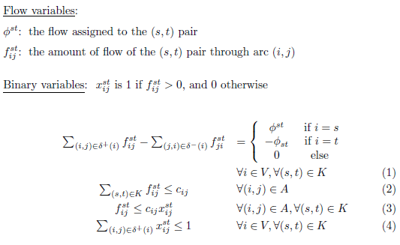

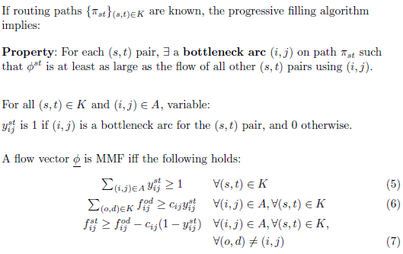

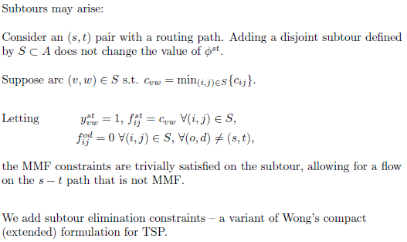

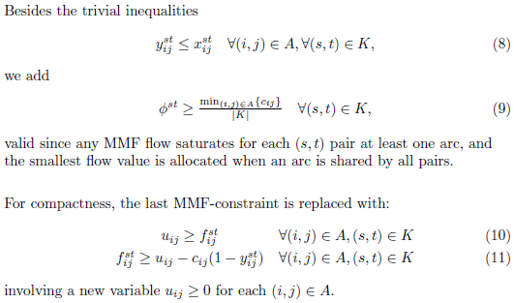

**Column Generation Algorithm**

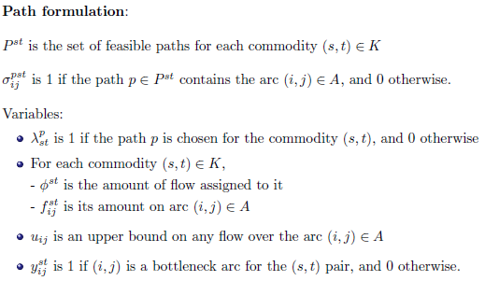

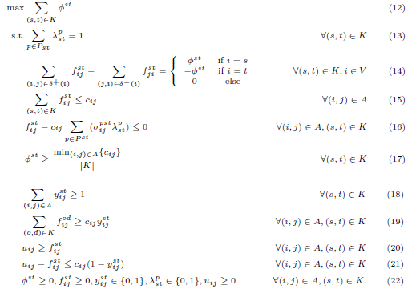

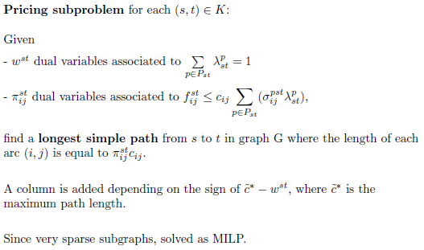

**MMF-constrained Traffic Engineering**

Let G = (V, A) be a directed graph representing the network topology with a capacity cij ≥ 0 for each arc (i, j) ∈ A and let K be a set of communications, speciﬁed by the corresponding origin-destination pairs (s, t), with (s, t) ∈ K.

Let φst denote the amount of bandwidth allocated to each origin-destination pair (s, t) ∈ K. As utility function,

|  |  |  |
| --- | --- | --- |
| we consider either the total weighted throughput | |  |
| max | wstφst, | (1) |
|  | (s,t)∈K |  |

Which is a simple weighted sum of the allocated band- widths with real weights wst, or

|  |  |  |
| --- | --- | --- |
| max | wstα(1 − eβ1φst) | (2) |
|  | (s,t)∈K |  |

For suitable α, β > 0, which favors the increase of a small bandwidth rather than of a large one. The latter function is linearized by means of the standard linear programming piecewise-aﬃne approximation of concave functions, see for instance [9], with 6 pieces. This amounts to introducing a single continuous variable per origin-destination pair and a linear constraint per piece.

A MMF ﬂow (bandwidth) allocation is formally deﬁned as follows. Let φ ∈ R|+K| be the vector of ﬂows, with one component per origin-destination pair. Let σ be the sorting operator that permutes the components of a vector in non-decreasing order. φ is MMF if and only if, for any

other vector φ′ ∈ R|+K|, σ(φ) lexicographically dominates σ(φ′), that is, either σ(φ) = σ(φ′) or there exists an integer l, with 1 ≤ l ≤ |K|, such that σ(φ)l > σ(φ′)l and σ(φ)k = σ(φ′)k for all ≤ k < l. In other words, if any other

ﬂow vector allocates more ﬂow to an origin-destination pair, then it allocates less to another origin-destination pair receiving a smaller ﬂow. The reader is referred to [1].

The following example illustrates the substantial difference between our MMF-constrained traﬃc engineering problem where we look for a MMF solution w.r.t. a set of (single) routing paths that optimizes the objective function (1) with uniform weights wst, and the standard single path routing problem where we look for a solution which is overall MMF. The above has been used to explain an example in our PPT(slide 13 to 18) using the objective function (2).

Computational experiments have been carried out on a set of network topologies taken from the SND library. We consider 4 networks (polska, n = 12,m = 18, abilene, n = 12,m = 15, nobel-us, n = 14,m = 21, atlanta, n = 15,m = 22) and generate, for each of them, four instances by adopting a different set of origin- destination pairs, for a total of 20 instances. Since capacities are not provided for SND library instances, we assume, for simplicity, that every link has the same capacity of 1000 Mbps. At the end of this section, we also comment on the results obtained for random capacities. The computational experiments are carried out on a machine equipped with 4 Intel i5 processors and 16 GB of RAM. A time limit of 3600 seconds is imposed. For simplicity, we assume that all the communications have the same weight wst = 1. In the objective function (2), we let α = 1000 and β= 200.

Table I reports the results obtained when optimizing the linear sum of the throughputs, namely objective function (1). Within the time limit, 10 out of 20 instances are solved to optimality. Overall, the integrality gap is quite small, below 3% on average. The two restricted path formulations with predefined random paths are much easier to solve, as shown by the substantially smaller integrality gap (< 1% and < 1.6%, respectively). Notably, the model with 10 (respectively 20) random paths is solved, on average, in less than 4% (6%) of the computing time needed to tackle the complete MILP model. The geometric mean of the ratios between the objective function value of the solutions found with the restricted path models and the exact one show a loss of less than 20% in solution quality for the restricted model with 10 paths per origin-destination pair and, most interestingly, an improvement of 2% for that with 20 paths.

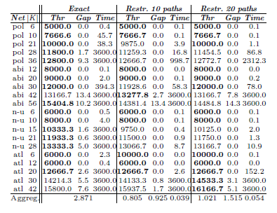

Table II reports the results obtained when optimizing the piecewise affine utility function (2).

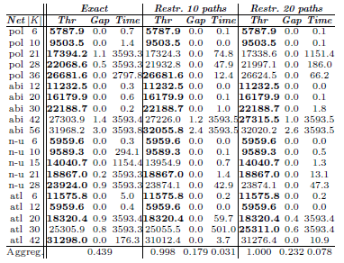

Interestingly, 12 out of 20 instances are solved to optimality within the time limit. Since this utility function is not as flat as the linear sum of throughputs, it may yield solutions with more varied bounds allowing for a heavier pruning in the branch-and-bound tree, possibly explaining the faster convergence that we observe. Indeed, on average, the integrality gap is smaller than 0.5%. Even for the 8 instances for which we did not find an optimal solution, the best solution found is still very close to be optimal. The two restricted path models with 10 (respectively 20) paths are solved within a gap smaller than 0.2% (0.24%), in 3% (8%) of the time needed to solve the exact formulation. Quite interestingly, they yield very high quality solutions which are almost equivalent, in terms of the piecewise-affine utility, to those obtained with the exact formulation.

Due to the lack of space, we do not report the detailed results obtained for the instances with non-uniform capacities. We just mention that our exact MILP formulation with objective function (1) could, in some cases, be solved to optimality substantially faster (possibly due to the reduced problem symmetry) and that the restricted path models tend to provide slightly worse quality solutions.

**Conclusions**

We have proposed a traffic engineering problem where, given a network topology with link capacities and a set of communications, we must select a single path for each communication so as to maximize a network utility function, assuming a MMF bandwidth allocation. We have shown that this problem can be cast as a single mixed-integer linear program with a polynomial number of variables and constraints, which is solvable in a reasonable amount of computing time for medium-size networks.